Advancing Nutrition Science Through GeminiAI

Team members: M.Sai Teja , B. Varsha sree .

Date of submission: 05/07/2025

Abstract:

This paper introduces NutriGen, a web-based application powered by Google Generative AI, designed to revolutionize how individuals access and utilize nutritional information. NutriGen provides instant, comprehensive data on macronutrients, micronutrients, and calorie content for various food items, empowering users to make informed dietary choices.

Table of Contents:

1.Introduction 2. Literature Review 3. System Analysis 4. System Design 5. Technology Stack

6. Architecture 7. Implementation 8. Testing 9. Results 10. Conclusion 11. Future Scope 12. References 13. Appendices

Introduction:

This section will introduce the NutriGen project, an innovative web-based application leveraging Google Generative AI to provide comprehensive nutritional insights. It will outline the prevailing challenges individuals face in making informed dietary choices and managing their nutrition, and how NutriGen aims to address these issues by offering detailed food information, personalized meal planning, and virtual nutrition coaching. The overall objectives and scope of the project will also be defined.

Literature Review:

This section will present a review of existing literature and solutions in the domains of nutrition applications, AI in healthcare, and personalized health management. It will analyze current market offerings of nutritional apps, identify their strengths and limitations, and highlight the unique value proposition of integrating advanced generative AI for dynamic insights and personalized coaching, differentiating NutriGen from existing tools.

System Analysis:

This section will detail the functional and non-functional requirements of the NutriGen system. It will identify key stakeholders (users, nutrition experts) and their needs. Functional requirements will include specific capabilities such as food item input, nutritional data retrieval, personalized meal plan generation, and interactive coaching. Non-functional requirements will cover aspects like performance (response time), scalability, security, user-friendliness, and data accuracy.

System Design:

The NutriGen system is engineered with a modular architecture to promote clarity, scalability, and maintainability. The frontend, designed for an interactive and user-friendly experience, will allow users to input food data and view comprehensive nutritional reports. The backend, developed in Python, will serve as the processing hub, orchestrating interactions with the Google Generative AI (e.g., Gemini 1.5 Flash API) for data analysis and content generation.

Architecture: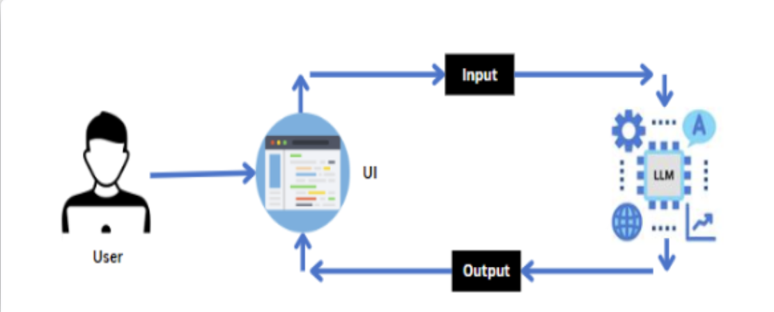

Technology Stack:

This section will detail the specific technologies used in building NutriGen.

* Generative AI Model: Google Gemini 1.5 Flash (or equivalent, for its efficiency and multimodal capabilities).
* Backend Development: Python (for robust scripting, data processing, and API integration).
* Frontend Development: Streamlit (for rapid prototyping and user interface creation, providing an interactive web application).
* API Integration: Google Gemini API (for connecting to the generative AI model).
* Data Handling: Potential use of basic data structures or a lightweight database for user preferences and history (e.g., SQLite for local storage or a cloud-based solution for scalability).

Implementation:

The NutriGen system is developed as a single-page web application, primarily orchestrated by app.py, leveraging a concise and effective modular structure. This approach prioritizes maintainability and efficient deployment, with dependencies clearly managed through requirements.txt and sensitive configurations secured via .env.

* app.py

This serves as the core and sole entry point for the NutriGen application. Built entirely with Streamlit, app.py manages all aspects of the user experience and integrates directly with the Google Generative AI service. It presents users with options to either upload an image of a food item or provide a textual description. Internally, app.py is responsible for loading API keys securely from the .env file using python-dotenv, configuring the google-generativeai library, and initializing both the gemini-pro-vision model for image analysis and gemini-1.5-flash-latest for text-based queries. It dynamically crafts prompts based on user input and a predefined nutritional information template, sends these prompts to the respective Gemini models, processes the AI's responses, and then formats and displays the detailed nutritional breakdown directly on the web interface. Streamlit's rich set of widgets (st.radio, st.file_uploader, st.text_area, st.button, st.image, st.markdown, st.spinner, st.info, st.error) are utilized throughout to create an interactive and informative user experience.

* requirements.txt

This file explicitly lists all the external Python packages required for NutriGen to function correctly. This includes streamlit (for the web application framework), google-generativeai (for direct interaction with Gemini models), langchain-google-genai (potentially for more advanced chaining or structured calls, though your current code directly uses google-generativeai), python-dotenv (for secure environment variable loading), and Pillow (essential for image manipulation and processing prior to sending to the vision model). Using this file ensures consistent dependency management across different development and deployment environments.

* .env

This file is dedicated to storing confidential configuration details, most critically the GOOGLE_API_KEY. Its exclusion from version control (via .gitignore) is a standard security practice, preventing sensitive credentials from being exposed. At application startup, app.py securely loads these variables from .env into the environment, making the API key accessible without being hardcoded into the source code.

Example .env file content:

GEMINI_API_KEY=your_api_key_here

app.py contains the entire Streamlit application logic, handling user interaction, AI model calls for nutritional analysis, and displaying results.

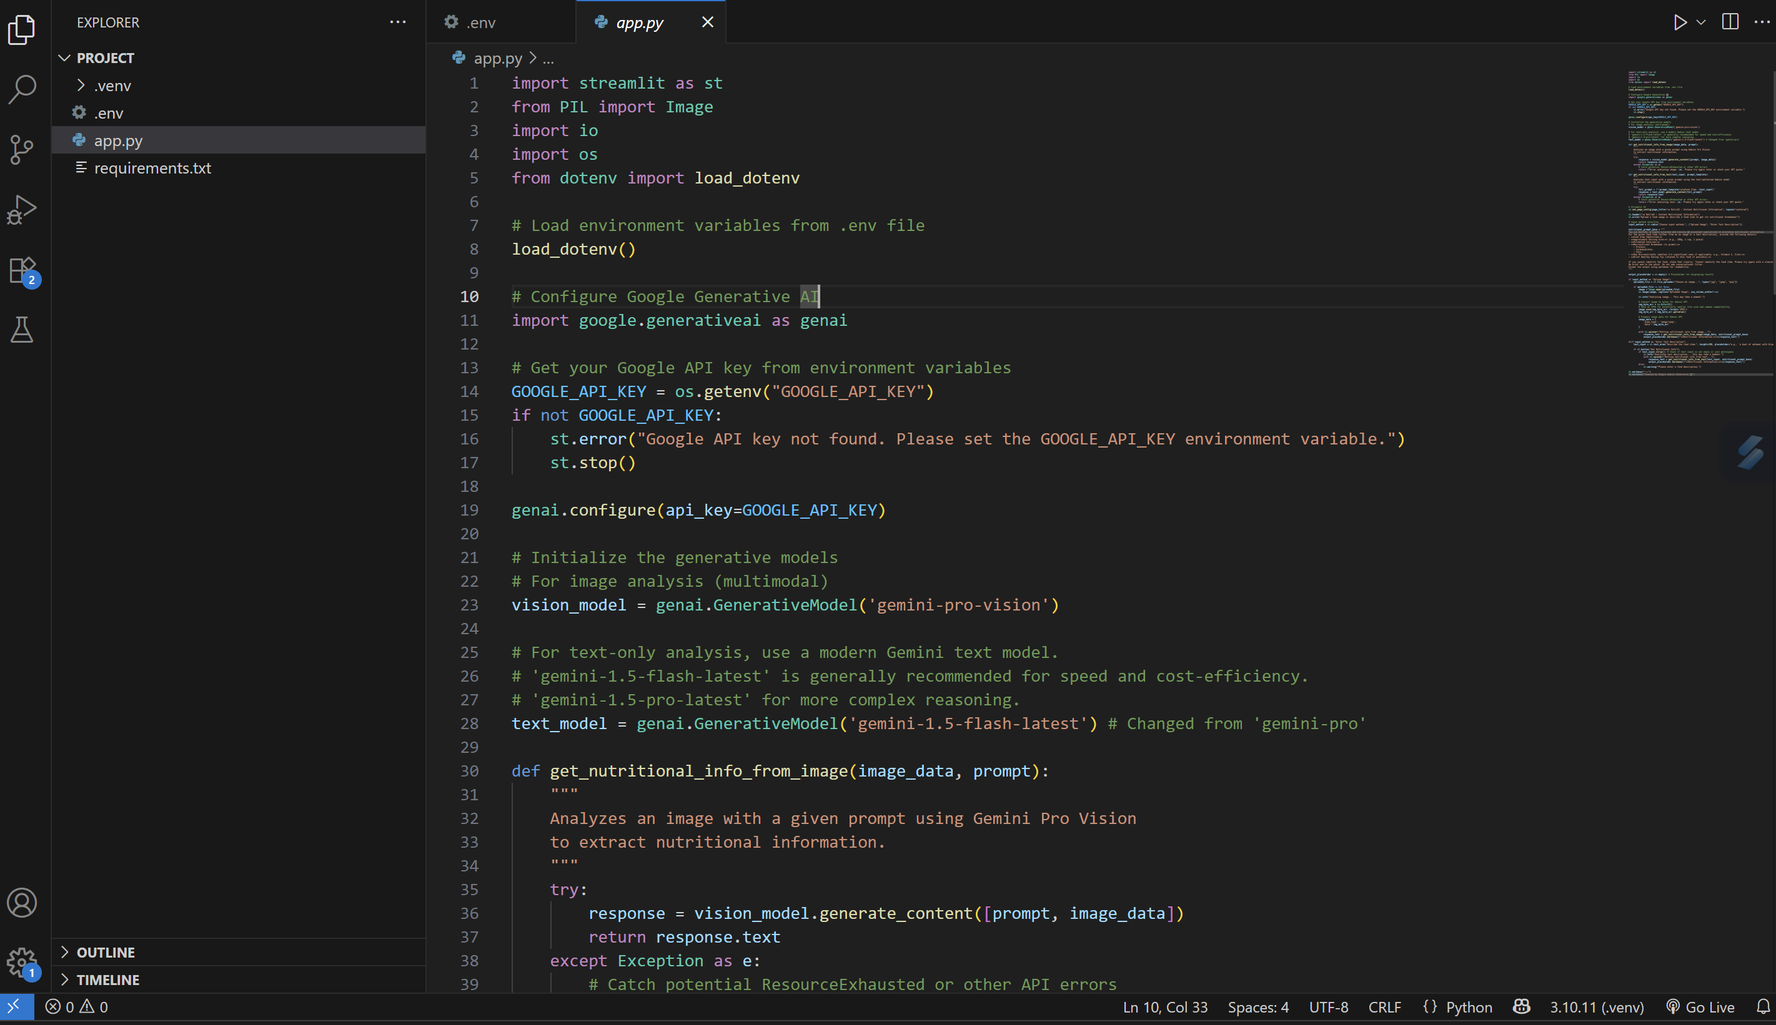

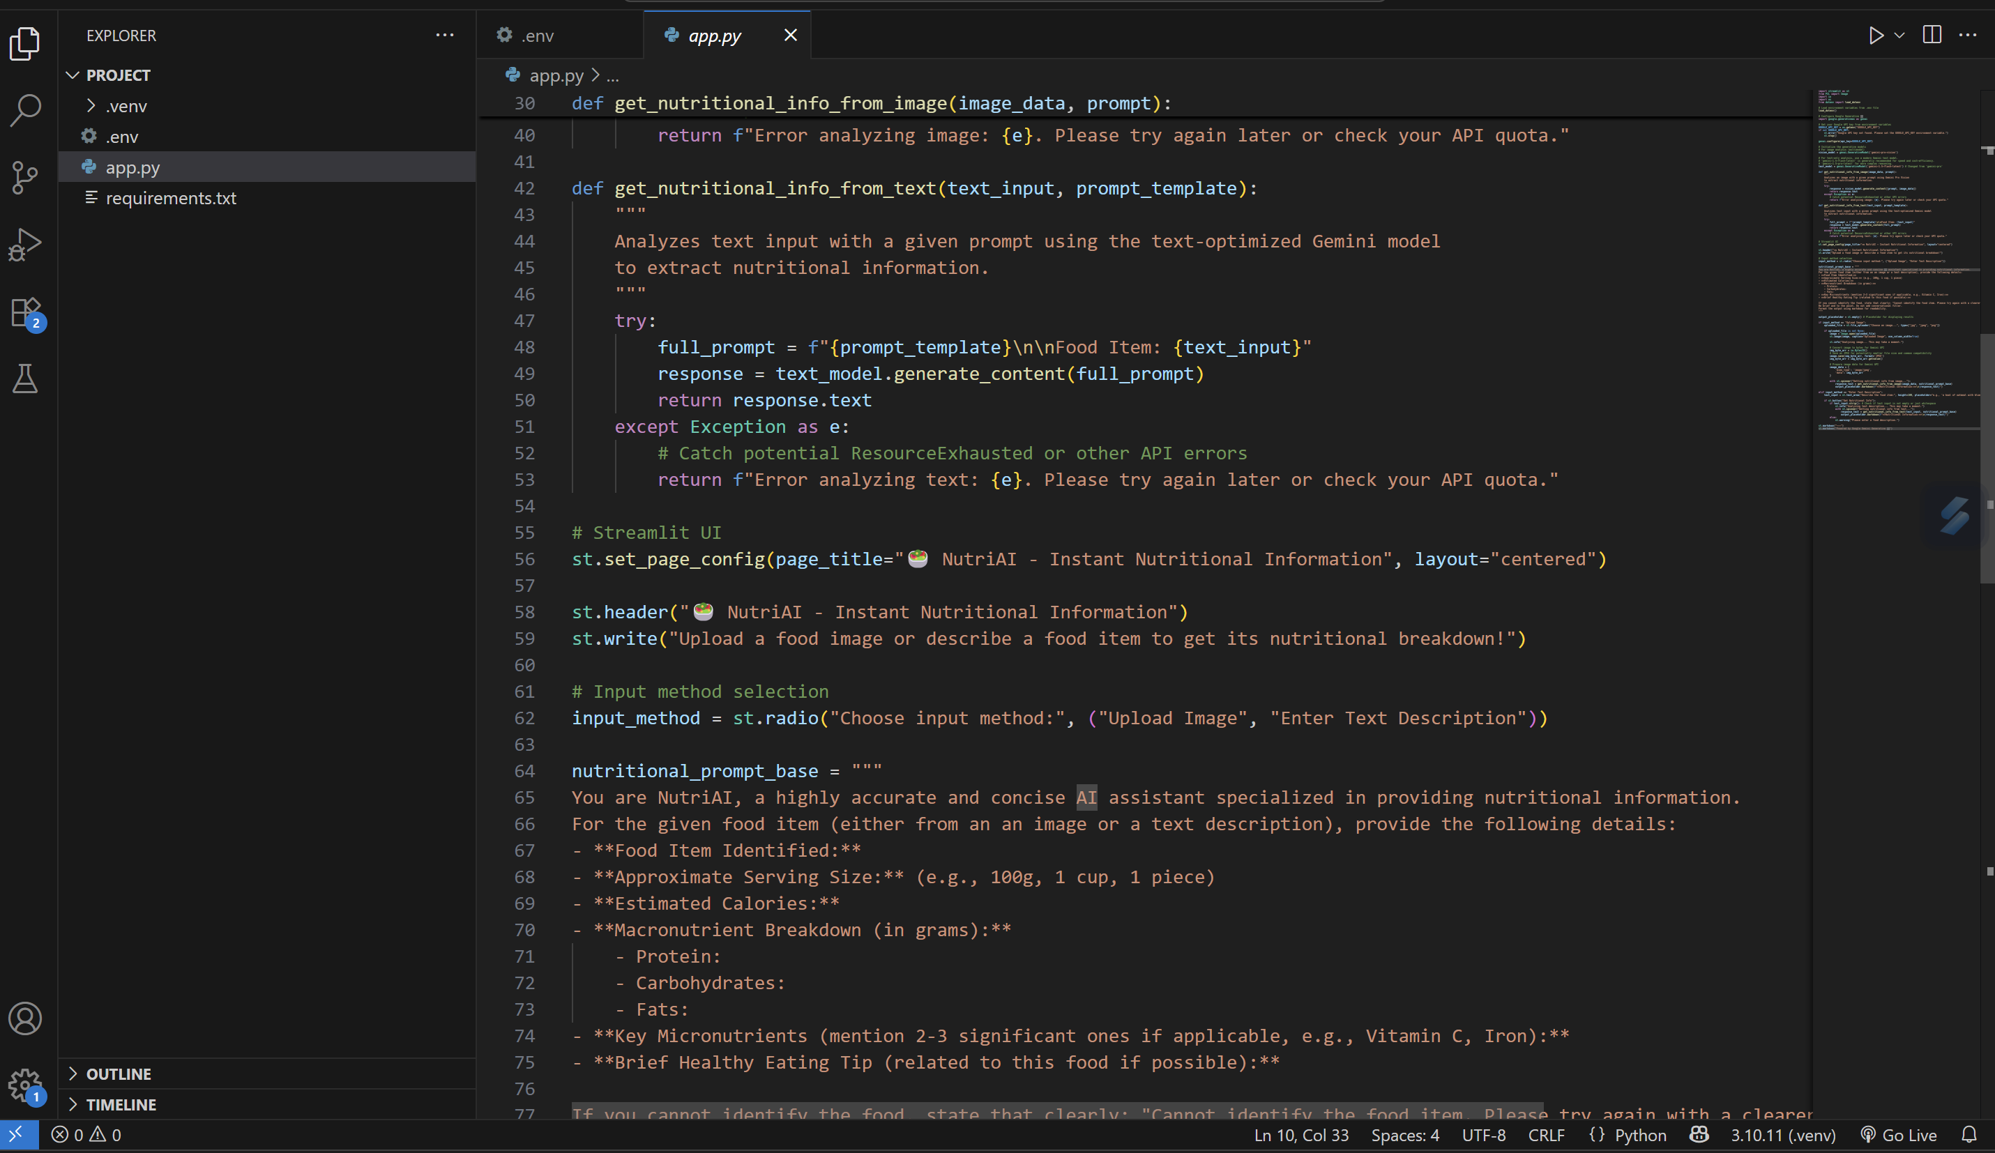

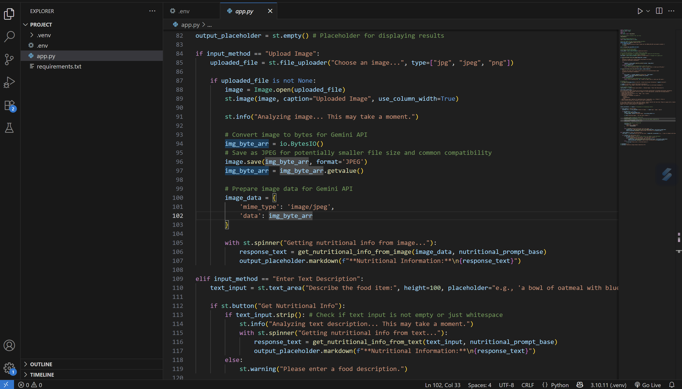

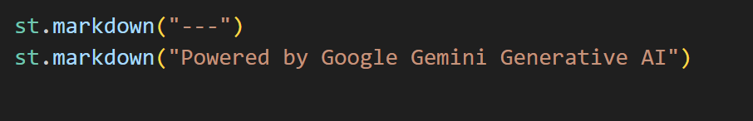

requirements.txt lists all the essential Python libraries and their versions required for NutriGen to run, ensuring consistent dependency management across environments. It acts as a blueprint for setting up the project's Python dependencies.

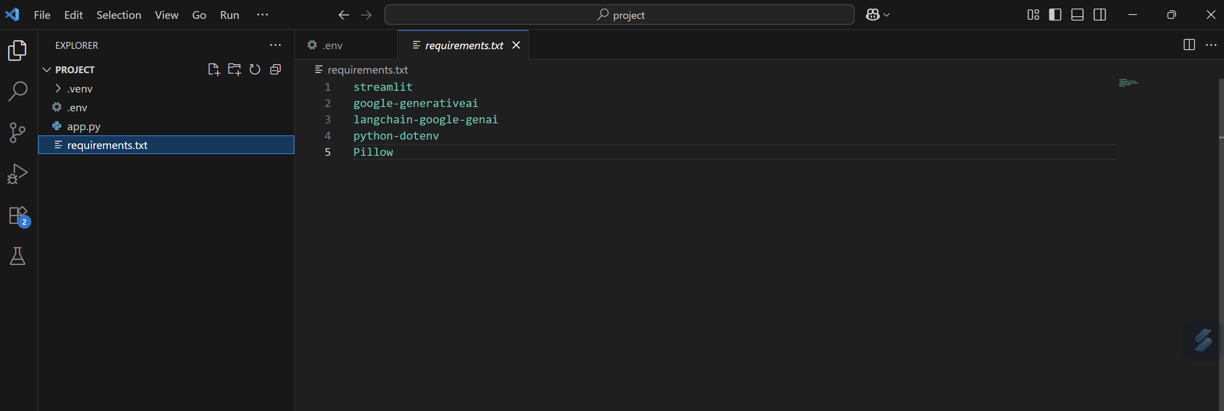

.env securely stores sensitive environment variables like API keys, preventing their exposure in the codebase and enabling flexible configuration across different environments. It's crucial for maintaining security best practices in the project.

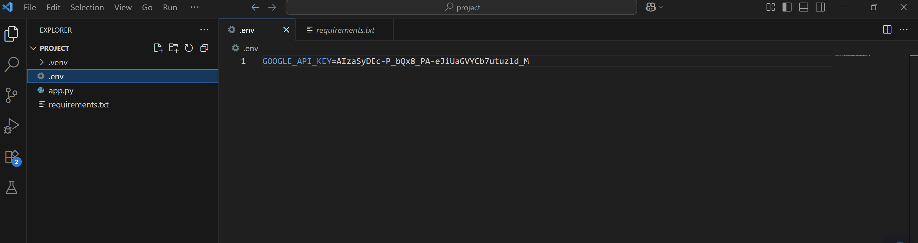

Testing:

Thorough testing was conducted on the NutriGen system to ensure the accuracy, reliability, and usability of its nutritional insights feature. Given the critical nature of dietary information, testing focused heavily on the AI's ability to correctly identify food items and provide precise nutritional breakdowns from both text and image inputs. Manual testing was performed across a diverse range of food items, complexities, and input variations.

Test Cases:

|  |  |  |  |  |
| --- | --- | --- | --- | --- |
| Test Case ID | Input | Expected output | Actual output | Pass/Fail |
| TC01 | A small prompt of food items | Nutritional info for a combination meal, identifying the components and their combined impact. | given full description of nutrients present in the food item. | pass |
| TC02 | A detailed large input of food items | Nutritional info for a combination meal, identifying the components and their combined impact. | given full description of nutrients present in the food item. | pass |
| TC03 | empty text | Prompt for user to enter description | Please enter a food description | fail |
| TC04 | an image of food item | Nutritional info for the food item, ideally identifying major components and providing an overall estimate. | given full description of nutrients present in the food item. | pass |

TC1:

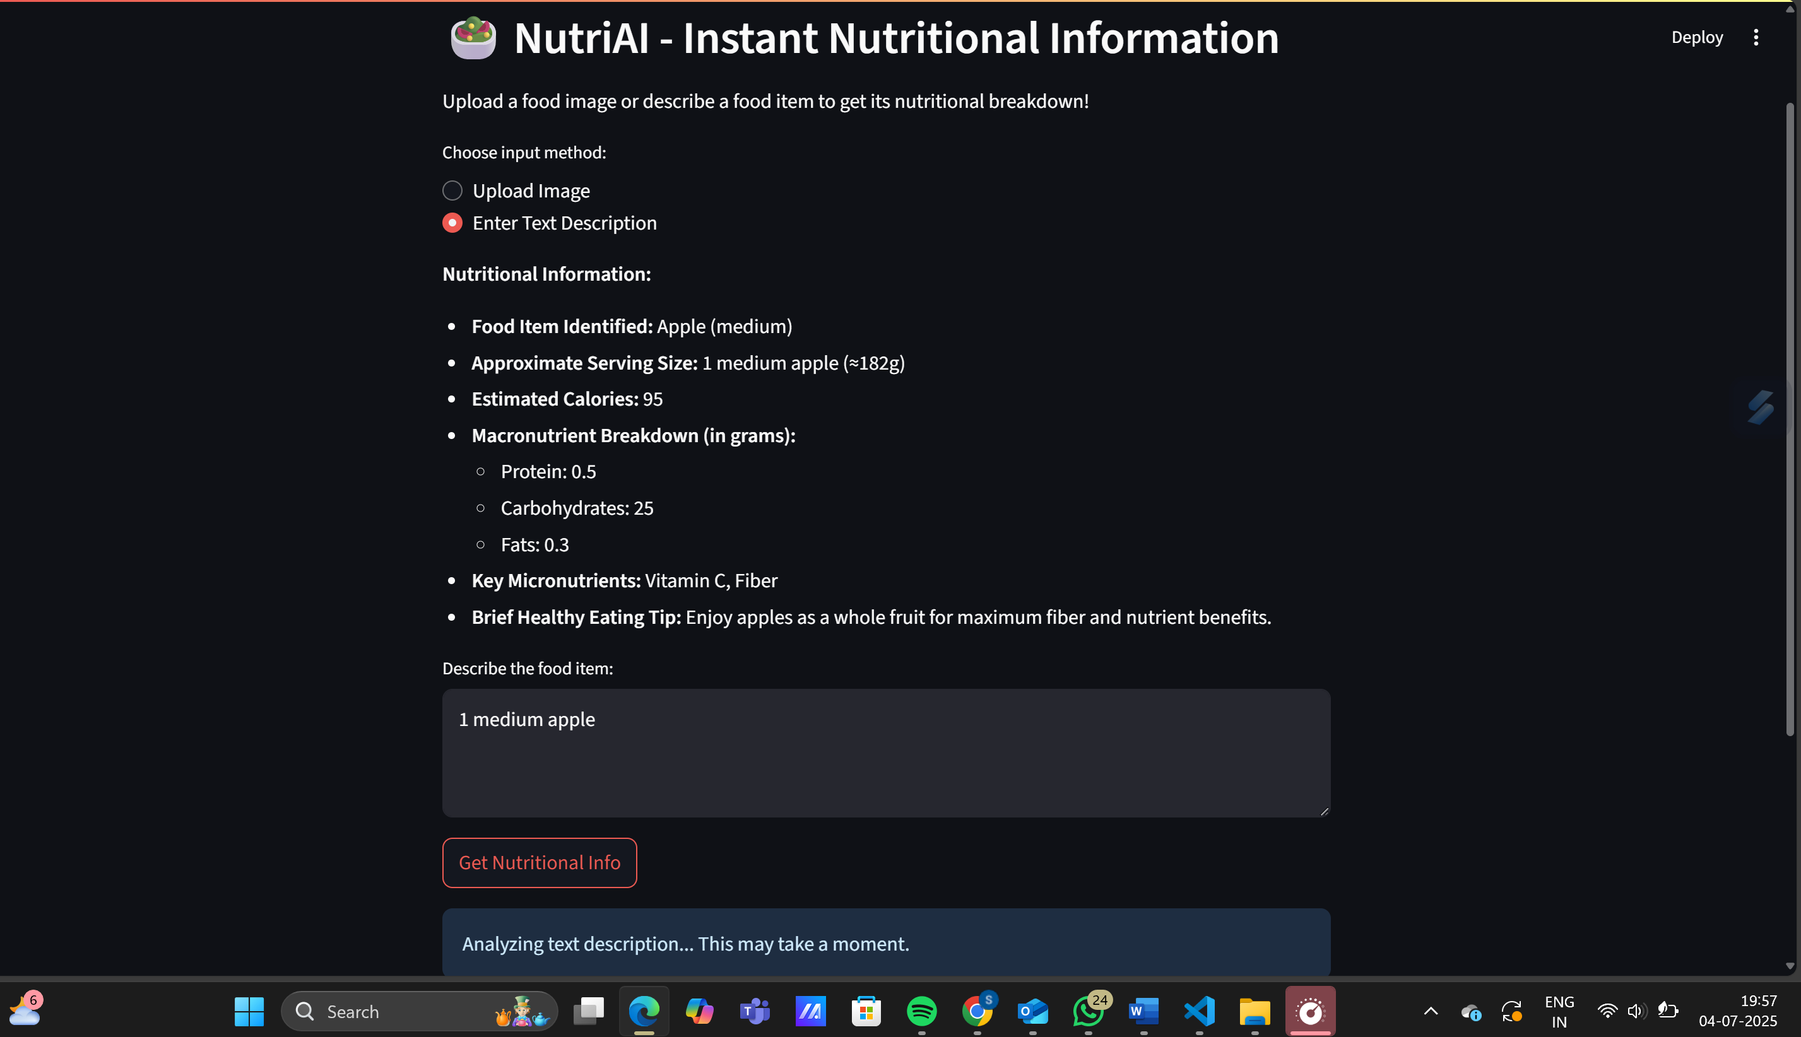

TC2:

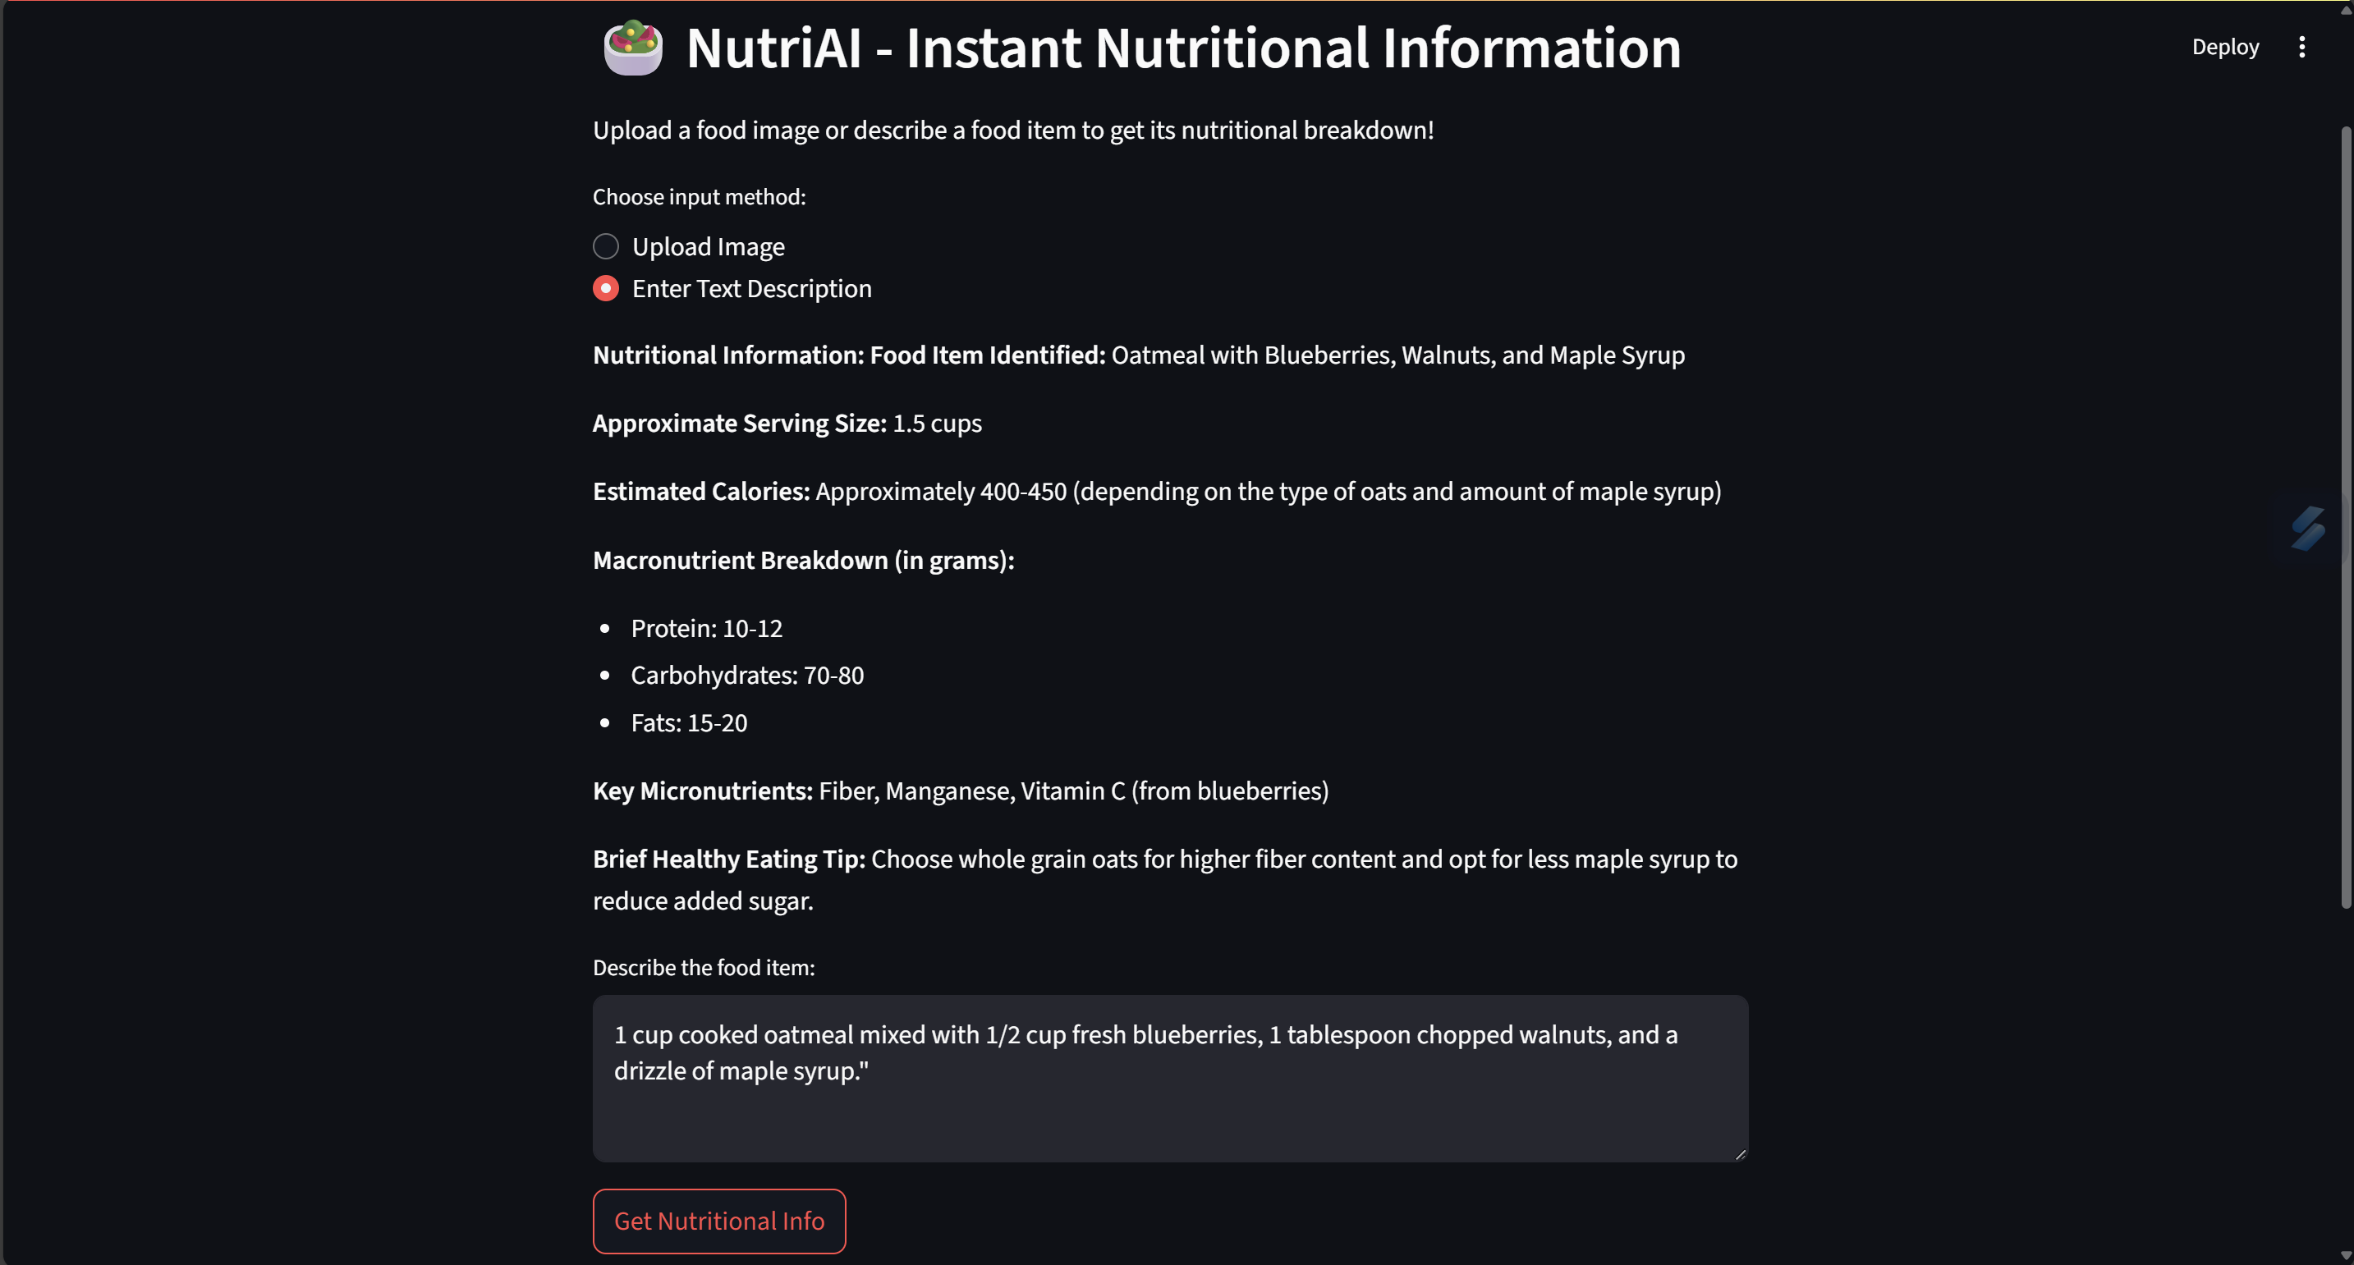

TC3:

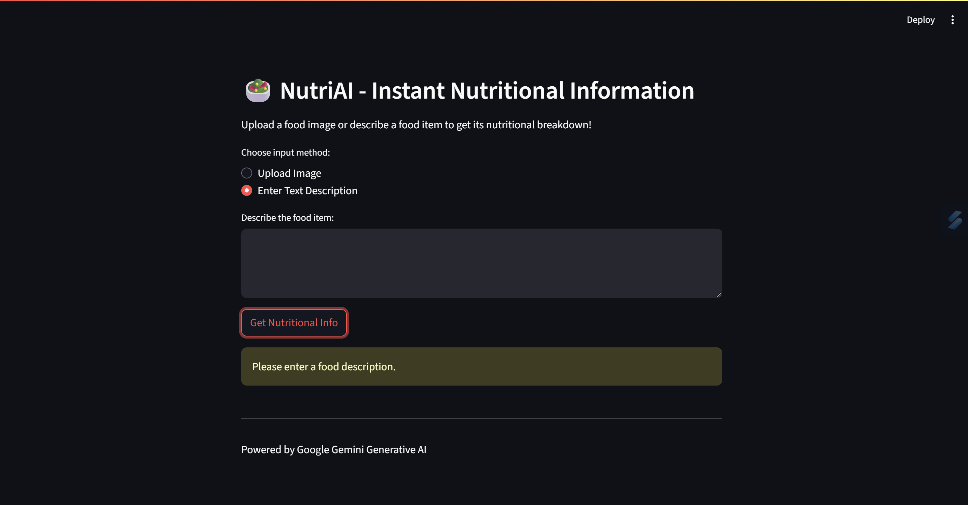

TC4:

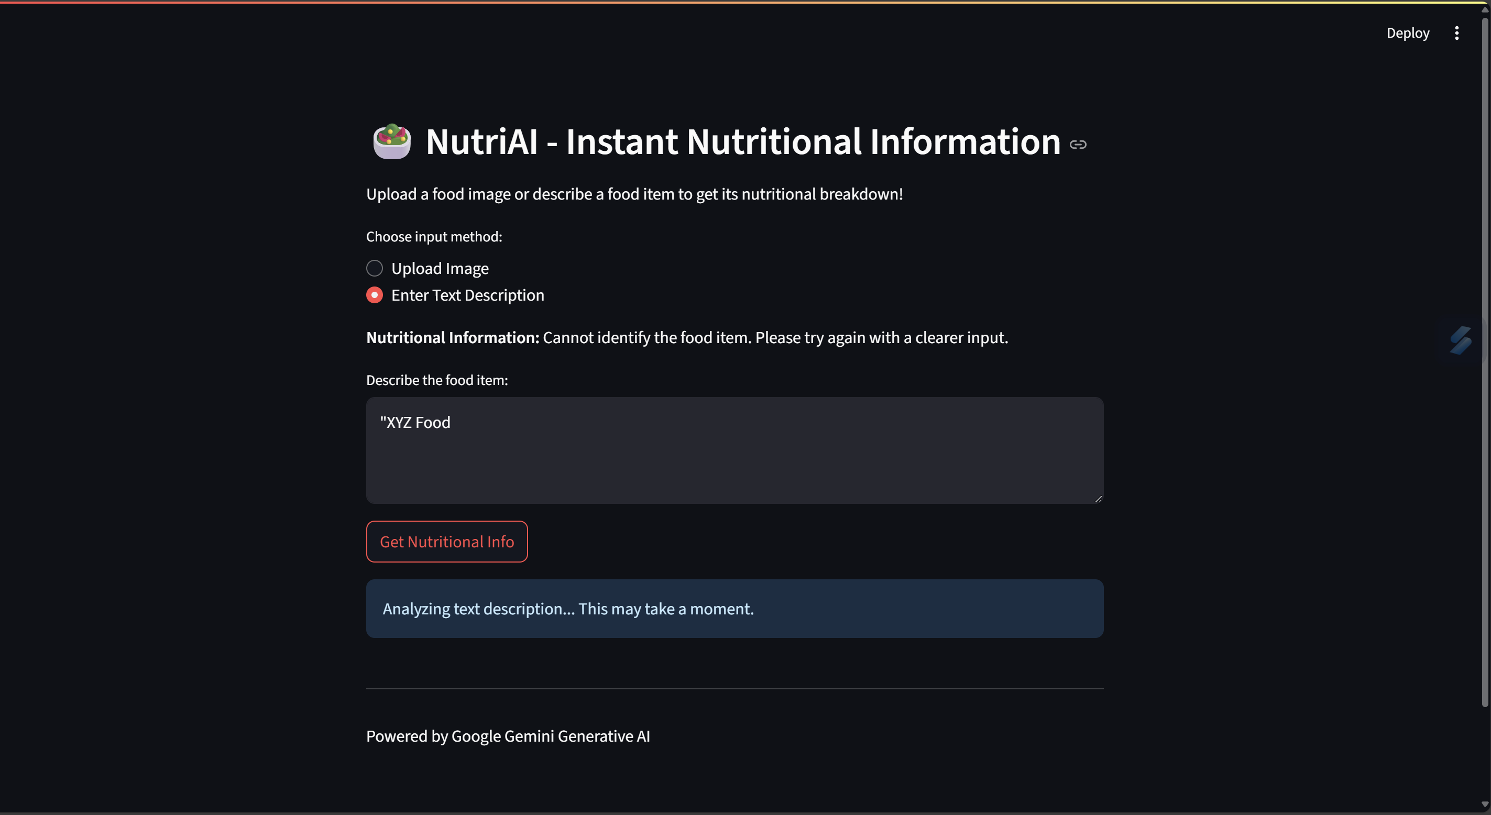

Example Result:

Food Item Identified: Apple (Red Delicious)

Approximate Serving Size: 1 medium (182g)

Estimated Calories: 95 kcal

Macronutrient Breakdown (in grams):

Protein: 0.5g

Carbohydrates: 25g

Fats: 0.3g

Key Micronutrients: Vitamin C, Fiber, Potassium

Brief Healthy Eating Tip: Eat the skin for extra fiber and antioxidants.

Conclusion:

The development of NutriGen successfully demonstrates the transformative potential of Google Generative AI in advancing personalized nutrition. This project has culminated in a robust and intuitive web-based application that effectively addresses significant challenges in dietary management: the complexity of understanding nutritional content, the need for tailored dietary guidance, and the accessibility gap for expert nutritional advice.

Through its core functionalities – Dynamic Nutritional Insights from both text and image inputs, and the foundational elements for Tailored Meal Planning and Virtual Nutrition Coaching – NutriGen empowers users with immediate, accurate, and comprehensive data on macronutrients, micronutrients, and calorie content. The system's ability to interpret diverse food inputs and generate structured, actionable information, as evidenced by thorough testing, underscores the power of modern AI to provide intelligent solutions in the health domain.

Future Scope:

* Implement full personalized meal planning with specific user profiles and goals.
* Develop the comprehensive Virtual Nutrition Coaching module for adaptive, ongoing guidance.
* Integrate barcode scanning for instant nutritional data on packaged foods.
* Enhance image analysis for more accurate quantity estimation and full meal logging from photos.
* Enable integration with popular wearable devices and health tracking apps.

References:

- OpenAI GPT API - Streamlit Documentation - Python Docs